**Final Term Paper FALL**-2019

**BSSE (Morning)**

**Computer Networks ( CS-577 )**

**Maximum Marks: 30 Total Time: 1:45Hr**

**Instructions: Attempt all Questions and solve all parts of a Question together in a sequence.**

**Question N0. 1 (10min) [Marks: 2+2=4]**

1. Explain with diagram that how Mobile IP works? (Only Labeled diagram is required).
2. Can we assign two IP address to a gateway and how it works? Explain with the help of diagram.

**Question N0. 2 (10min) [Marks: 4]**

Why doesn’t collision detection work well in wireless networks? (describe a scenario where this doesn’t work.)

**Question N0. 3 (10min) [Marks: 4]**

Draw the routing table for R1 including default entry

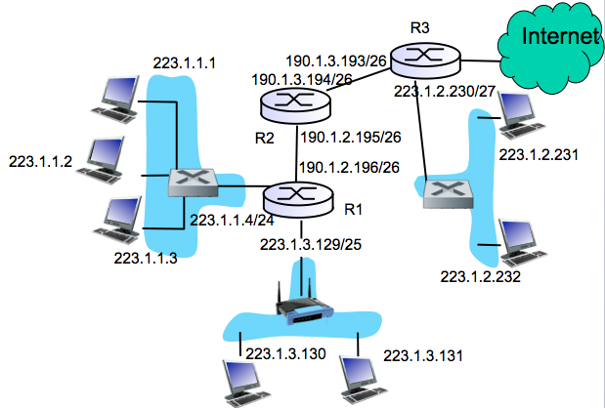

**Question N0. 4 (15min) [Marks: 2+4=6]**

1. Why the control connection in FTP is called out of band?
2. In DNS name resolution if a host at uaar.edu.pk want IP address of Stanford.cs.edu then with the help of diagram explain the working of iterated query method (local DNS server at UAAR data center does not know the IP address of Stanford.cs.edu)

**Question N0. 5 (15min) [Marks: 2+4=6]**

1. Draw and fill (??) the Seq no and ACK no for the following figure.
2. Fill and Label the following figure for TCP Header structure.

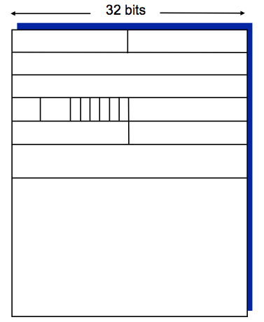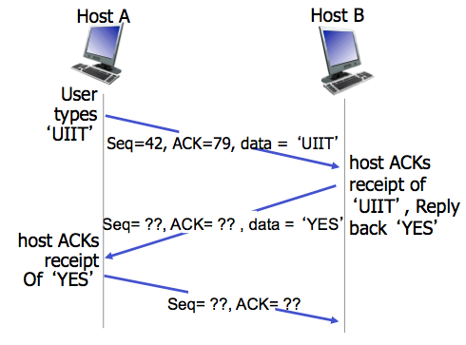

**Question N0. 6 (15min) [Marks: 2+4=6]**

1. What do you think that between TCP Reno or TCP Tahoe, which one is better and why (Just 2-3 line)
2. Draw the TCP Reno graph with the following information. At round 1 cwnd=1, Initial threshold is 30, Received 3ACK at round no 10, Timeout occurs at round no 17, draw graph till round no 25.

**\*\*\*\*Good Luck\*\*\*\*\***

**Final Paper FALL**-2019

**BSSE (Morning)**

**Computer Networks ( CS-577 )**

**Maximum Marks: 20 PRACTICAL Total Time: 45 min**

**Instructions: Attempt all Questions and solve all parts of a Question together in a sequence.**

**Question N0. 1 (30min) [Marks: 6+2+2]**

1. Draw the network diagram using following addressing Table.
2. How many separate networks in the system?
3. How you configure the router R1 for assignment of IP address and static routing.

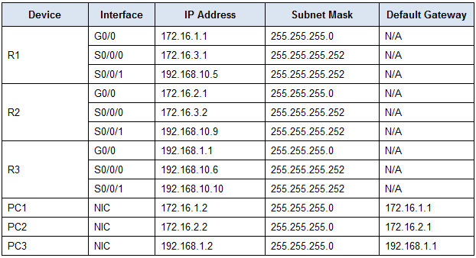

**Question N0. 2 (10min) [Marks: 4]**

What is the Network ID, Broadcast Address, and first & last valid IP on the subnetwork that the host 192.168.2.13/26 belongs to?

**Question N0. 3 (05min) [Marks: 6]**

Write down network design semester project introduction (4-5 lines)

.

**\*\*\*\*Good Luck\*\*\*\*\***